ER Diagram:-

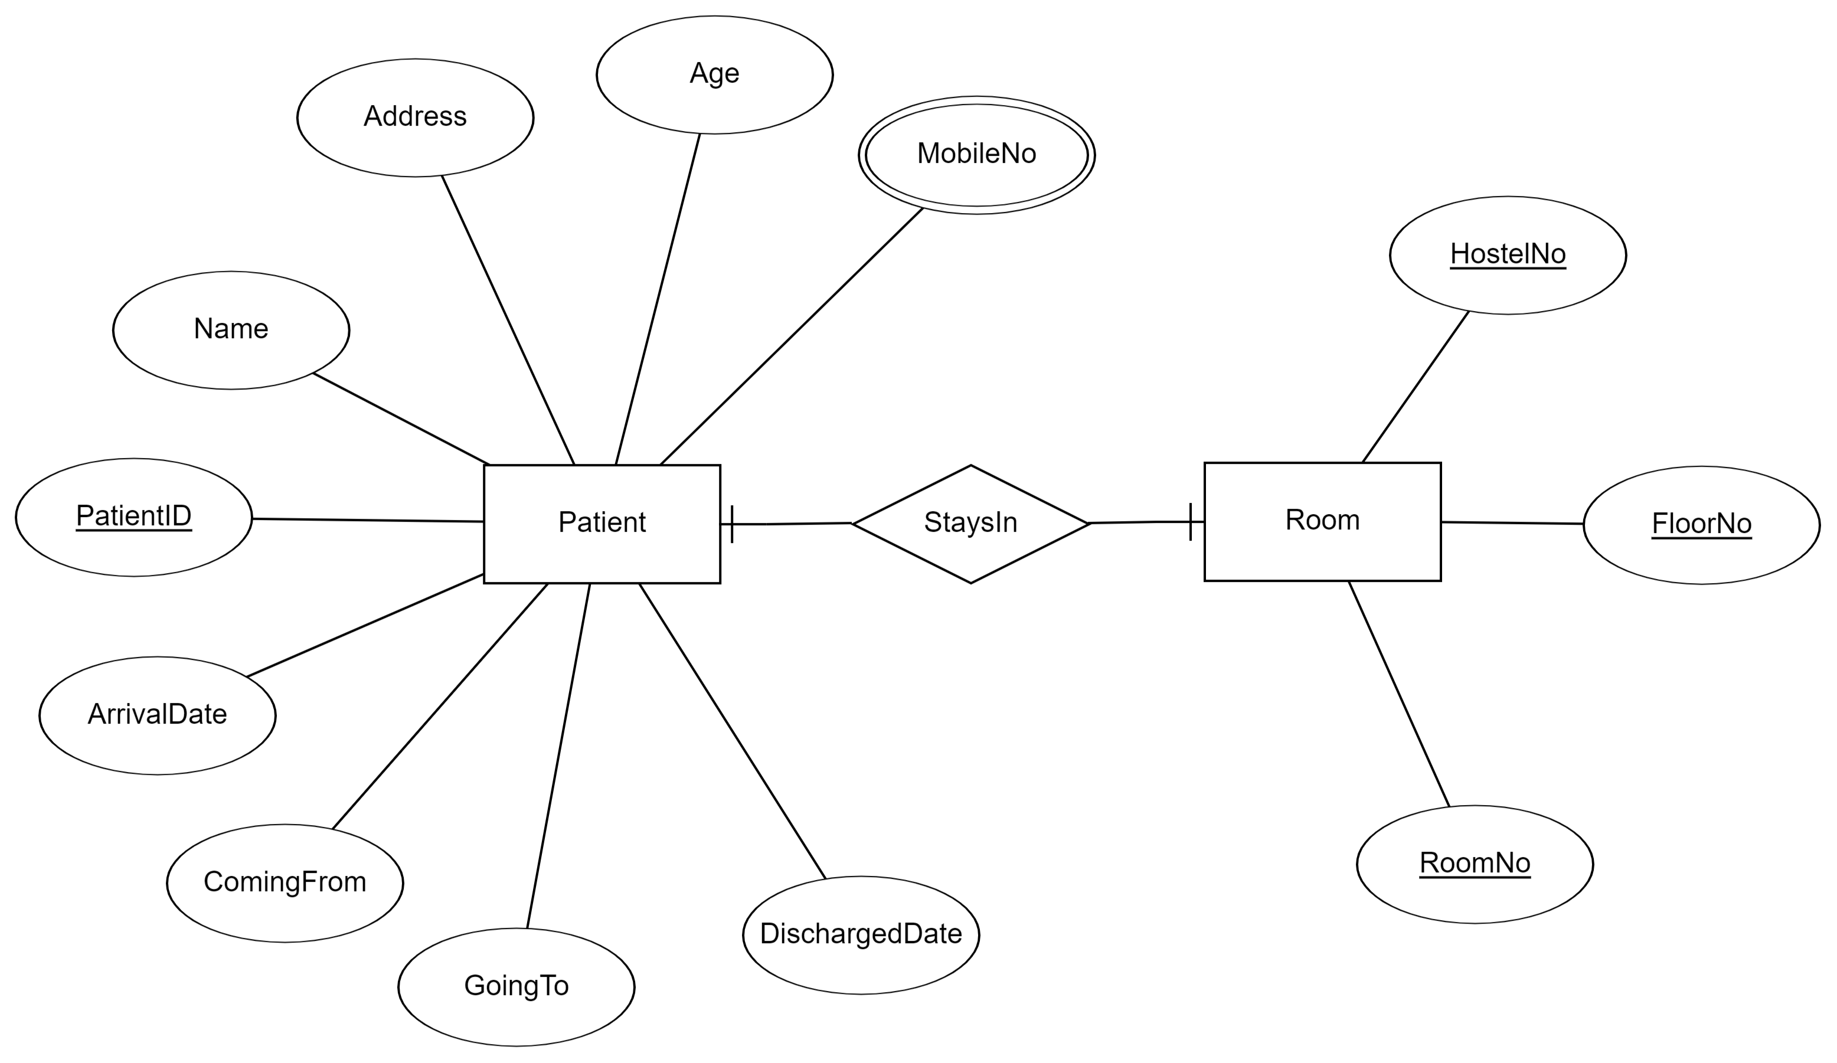

Relational Schema:-

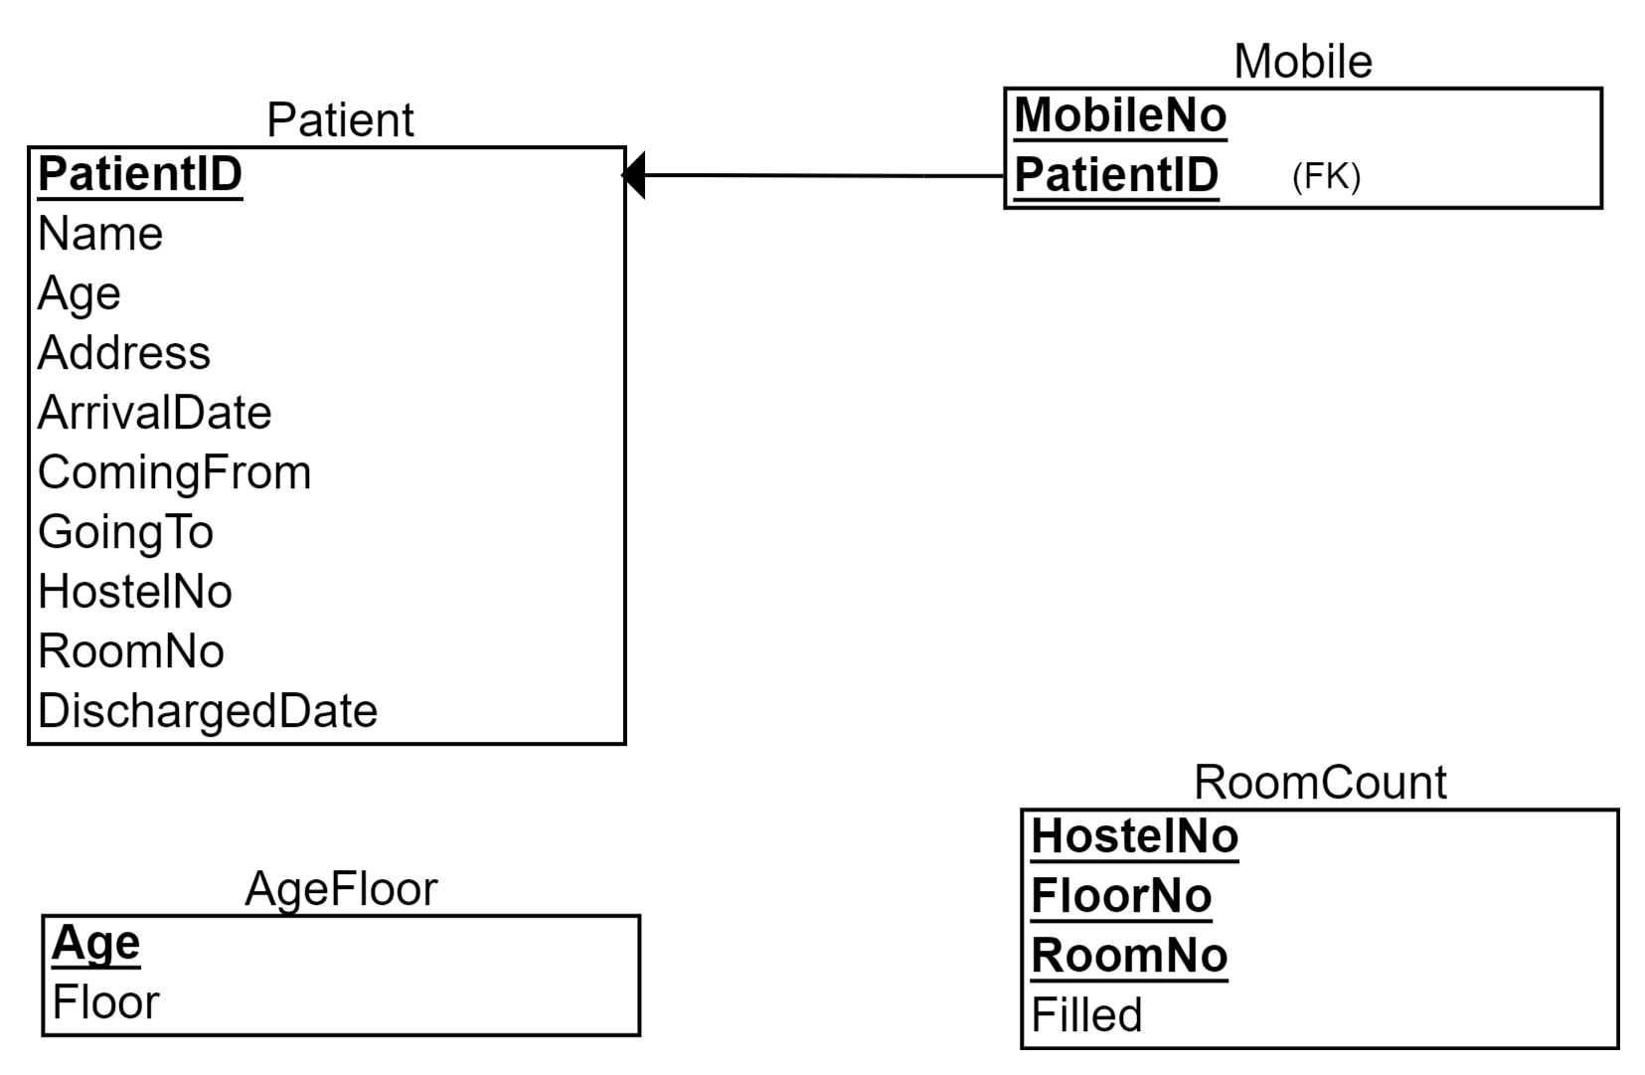

-- #Schema Creation on MariaDB
-- -----------------------------------------------------
-- Schema quarantine
-- -----------------------------------------------------
CREATE SCHEMA IF NOT EXISTS `quarantine` DEFAULT CHARACTER SET utf8;
USE `quarantine`;
-- #Table Creation
-- -----------------------------------------------------
-- Table `quarantine`.`patient`
-- -----------------------------------------------------
CREATE TABLE `quarantine`.`patient` (
`PatientID` INT NOT NULL,
`Name` VARCHAR(45) NULL,
`Age` INT NULL,
`Address` VARCHAR(45) NOT NULL,
`ArrivalDate` DATE NULL,
`ComingFrom` VARCHAR(45) NULL,
`GoingTo` VARCHAR(45) NULL,
`HostelNo` INT NULL,
`RoomNo` VARCHAR(5) NULL,
`DischargedDate` DATE NULL,
PRIMARY KEY (`PatientID`))
ENGINE = InnoDB;
CREATE TABLE `quarantine`.`mobile` (
`MobileNo` VARCHAR(10) NOT NULL,
`PatientID` INT NOT NULL,
PRIMARY KEY (`MobileNo`, `PatientID`),
INDEX (`PatientID`),
CONSTRAINT `PatientID`
FOREIGN KEY (`PatientID`)
REFERENCES `quarantine`.`patient` (`PatientID`)
ON DELETE CASCADE
ON UPDATE CASCADE);
CREATE TABLE `quarantine`.`AgeFloor` (
`Age` INT NOT NULL,
`Floor` INT NOT NULL,
PRIMARY KEY (`Age`, `Floor`),
INDEX (`Age`)
);

CREATE TABLE `quarantine`.`roomcount` (
`HostelNo` INT NOT NULL,
`FloorNo` VARCHAR(45) NOT NULL,
`RoomNo` VARCHAR(45) NOT NULL,
`Filled` INT NULL,
PRIMARY KEY (`HostelNo`, `FloorNo`, `RoomNo`));
================================================================
Assuming that mobile no can be same for two different patients,
using an arbitrary number as ID in different entity
or
using both {mobile number and patient ID} as primary key.
================================================================

In insertion SP, check if each hostel is full.

If in insertion both hostels are full, insertion should return error message to GUI
=====================================================
[Constraints :-
Each Hostel
ground floor with 100 rooms,
1st floor with 100 rooms and
2nd floor with 50 rooms only.
So, the total no. of rooms per quarantine centre is 250.

ground floor rooms will be allotted to senior citizens (above 60 yrs of age),
1st floor with be allotted to the persons in the
age group of 40 yrs to 60 yrs and

the 2nd floor will be allotted to persons below 40 yrs.

single occupancy room. i.e. room no is unique

{Optional:-
1) will likely to be quarantined for 14 days.

2) Automatic Assignment to First empty room.
}

]
=======================================================

After deciding on the attributes, SP and triggers:-
→ ER diagram creation
→ Normalisation Check upto 3NF is to be maintained

Create SP and Triggers

Normalisation:-

1. Patient

PatientID*
Name
Age
Address
ArrivalDate
ComingFrom
GoingTo
HostelNo
RoomNo
DischargedDate

2. MobileNumber

MobileNo* and PatientID*

3. AgeFloor

Age*
FloorNo

4. RoomCount

HostelNo
FloorNo
RoomNo
Filled

Not multivalued:- 1NF

1.

No multivalued attribute in table so 1NF.
Since no attribute determines another aside from PatientID, it is in 2NF and 3NF since LHS is PK.

#TODO
We assume or not that although around 14 days is needed for quarantine as DischargedDate, it could be changed by the admin according to needs.
Whatever the case, if 14 days is fixed, it depends on ArrivalDate other than PatientID, so it doesn’t show PD.

Hence, table in 2NF and 3NF

2.
No multivalued attribute in table so 1NF.
PatientID, MobileNo is PK. Assuming that there might be cases in which two people share a mobile number are quarantined then PatientID determines MobileNo and MobileNo can be non unique.
Given that patients may have multiple mobile numbers according to problem sttement.
Thus only PatientID, MobileNo together determine unique value.
No partial dependency hence 2NF
Thus LHS is PK and the table is in 3NF.

3.

Age*
Floor

No multivalued attribute in table so 1NF.
Age determines FloorNo
It is not partially dependent and hence in 2NF
Since LHS is PK(CK) hence in 3NF

4.

HostelNo*
FloorNo*
RoomNo*
Filled

No multivalued attribute in table so 1NF.
{HostelNo*, FloorNo*, RoomNo*} together determine Filled.
No PD.
∴ 2NF.
Since LHS is PK hence in 3NF

SP:-
InsertPatient_SP →
//////////////////////////////////////////
USE `quarantine`;
DROP procedure IF EXISTS `InsertPatient_SP`;
DELIMITER $$
USE `quarantine`$$
CREATE PROCEDURE `InsertPatient_SP` (
IN PatientID INT,
IN Name VARCHAR(45),
IN Age INT,
IN Address VARCHAR(45),
IN ArrivalDate DATE,
IN ComingFrom VARCHAR(45),
IN GoingTo VARCHAR(45)
)
BEGIN
INSERT INTO `quarantine`.`patient` (`PatientID`, `Name`, `Age`, `Address`, `ArrivalDate`, `ComingFrom`, `GoingTo`) VALUES (PatientID, Name, Age, Address, ArrivalDate, ComingFrom, GoingTo);
END$$
DELIMITER ;

////////////////////////////////////////////

////////////////////////////////

IN `HostelNo` INT,
IN `RoomNo` VARCHAR(5),
IN `DischargedDate` DATE
These three need to be inserted in trigger

UpdatePatient_SP →
////////////////////////////
DROP procedure IF EXISTS `quarantine`.`UpdatePatient_SP`;
;
DELIMITER $$
USE `quarantine`$$
CREATE DEFINER=`root`@`localhost` PROCEDURE `UpdatePatient_SP`(
IN uPatientID INT,
IN uName VARCHAR(45),
IN uAge INT,
IN uAddress VARCHAR(45),
IN uArrivalDate DATE,
IN uComingFrom VARCHAR(45),
IN uGoingTo VARCHAR(45)
)
BEGIN
UPDATE `quarantine`.`patient`
SET `Name`=uName, `Age`=uAge, `Address`=uAddress, `ArrivalDate`=uArrivalDate, `ComingFrom`=uComingFrom, `GoingTo`=uGoingTo
WHERE `PatientID` = uPatientID;
END$$
DELIMITER ;
;
////////////////////////////
Use update trigger to select new value as old value if left empty

//////////////////////////////

Above 2 handled by trigger

DeletePatient_SP → Cause
////////////////////////////////////////////
DROP procedure IF EXISTS `quarantine`.`DeletePatient_SP`;
;
DELIMITER $$
USE `quarantine`$$
CREATE DEFINER=`root`@`localhost` PROCEDURE `DeletePatient_SP`(
IN uPatientID INT
)
BEGIN
DELETE FROM `quarantine`.`patient` WHERE `PatientID` = uPatientID;
END$$
DELIMITER ;
;

////////////////////////////////////////////

#TODO or not
Another table Room could also be created to calculate empty rooms in each floor for ease of programming.

#TODO Possible Constraints/Triggers to be found
InsertMobile_SP
////////////////////////////////////////////
DROP procedure IF EXISTS `quarantine`.`InsertMobile_SP`;
;
DELIMITER $$
USE `quarantine`$$
CREATE DEFINER=`root`@`localhost` PROCEDURE `InsertMobile_SP`(
IN uPatientID INT,
IN uMobileNo VARCHAR(10)
)
BEGIN
INSERT INTO `quarantine`.`mobile`(`MobileNo`, `PatientID`) VALUES (uPatientID, uMobileNo);
END$$
DELIMITER ;
;
////////////////////////////////////////////

UpdateMobile_SP
////////////////////////////////////////////
DROP procedure IF EXISTS `quarantine`.`UpdateMobile_SP`;
;
DELIMITER $$
USE `quarantine`$$
CREATE DEFINER=`root`@`localhost` PROCEDURE `UpdateMobile_SP`(
IN uPatientID INT,
IN uMobileNo VARCHAR(10)
)
BEGIN
UPDATE `quarantine`.`mobile`
SET `MobileNo`=uMobileNo
WHERE `PatientID`=uPatientID;
END$$
DELIMITER ;
;
////////////////////////////////////////////

DeleteMobile_SP
/////////////////////////////////////////////
DROP procedure IF EXISTS `quarantine`.`DeleteMobile_SP`;
;
DELIMITER $$
USE `quarantine`$$
CREATE DEFINER=`root`@`localhost` PROCEDURE `DeleteMobile_SP`(
IN uPatientID INT
)
BEGIN
DELETE FROM `quarantine`.`mobile` WHERE `PatientID` = uPatientID;
END$$
DELIMITER ;
;
/////////////////////////////////////////////
Age – Floor Table should work like a dictionary to find suitable floor for age.

Triggers:-

Patient_Insert_Trigger
Before Insert Into Patient
check if floor already exists in age-floor else calculate
to assign room
check for floor from age table using age
check in hostel 1
If not check in hostel 2
else error log
#TODO if room-count table/view is created then update after assigning

DROP TRIGGER IF EXISTS `quarantine`.`patient_BEFORE_INSERT`;
DELIMITER $$
USE `quarantine`$$
CREATE DEFINER=`root`@`localhost` TRIGGER `quarantine`.`patient_BEFORE_INSERT` BEFORE INSERT ON `patient` FOR EACH ROW
BEGIN
declare fNo int;
declare gfloor int;
declare ffloor int;
declare sfloor int;
SET gfloor = 100;
SET ffloor = 100;
SET sfloor = 50;
-- Calculate Floor. Use as NEW.FloorNo
IF EXISTS(select agefloor.Floor from agefloor where agefloor.Age = NEW.Age) > 0 THEN
SET fNo = (select agefloor.Floor from agefloor where agefloor.Age = NEW.Age);
-- Just grab from agefloor table
ELSE
IF NEW.Age >= 60 THEN
SET fNo = 0;
END IF;
IF NEW.Age < 60 or NEW.Age > 40 THEN
SET fNo = 1;
END IF;
IF NEW.Age <= 40 THEN
SET fNo = 2;
END IF;
INSERT INTO agefloor (Age, Floor) values (NEW.Age, fNo);
-- Calculate Floor
END IF;
IF fNo = 0 THEN
IF (SELECT SUM(Filled) FROM roomcount where HostelNo = 1 and FloorNo = fNo and Filled = 0) <= gfloor THEN
SET NEW.RoomNo = (SELECT RoomNo FROM roomcount r where HostelNo = 1 and FloorNo = fNo and Filled = 0 limit 1);
SET NEW.HostelNo = 1;
ELSEIF (SELECT SUM(Filled) FROM roomcount where HostelNo = 2 and FloorNo = fNo and Filled = 0) <= gfloor THEN
SET NEW.RoomNo = (SELECT RoomNo FROM roomcount r where HostelNo = 2 and FloorNo = fNo and Filled = 0 limit 1);
SET NEW.HostelNo = 2;
END IF;
ELSEIF fNo = 1 THEN
IF (SELECT SUM(Filled) FROM roomcount where HostelNo = 1 and FloorNo = fNo and Filled = 0) <= ffloor THEN
SET NEW.RoomNo = (SELECT RoomNo FROM roomcount r where HostelNo = 1 and FloorNo = fNo and Filled = 0 limit 1);
SET NEW.HostelNo = 1;
ELSEIF (SELECT SUM(Filled) FROM roomcount where HostelNo = 2 and FloorNo = fNo and Filled = 0) <= ffloor THEN
SET NEW.RoomNo = (SELECT RoomNo FROM roomcount r where HostelNo = 2 and FloorNo = fNo and Filled = 0 limit 1);
SET NEW.HostelNo = 2;
END IF;
ELSEIF fNo = 2 THEN
IF (SELECT SUM(Filled) FROM roomcount where HostelNo = 1 and FloorNo = fNo and Filled = 0) <= sfloor THEN
SET NEW.RoomNo = (SELECT RoomNo FROM roomcount r where HostelNo = 1 and FloorNo = fNo and Filled = 0 limit 1);
SET NEW.HostelNo = 1;
ELSEIF (SELECT SUM(Filled) FROM roomcount where HostelNo = 2 and FloorNo = fNo and Filled = 0) <= sfloor THEN
SET NEW.RoomNo = (SELECT RoomNo FROM roomcount r where HostelNo = 2 and FloorNo = fNo and Filled = 0 limit 1);
SET NEW.HostelNo = 2;
END IF;
END IF;
UPDATE roomcount SET filled = 1 where HostelNo = NEW.HostelNo and FloorNo = fNo and RoomNo = NEW.RoomNo;
SET NEW.DischargedDate = (SELECT DATE_ADD(NEW.ArrivalDate, INTERVAL 10 DAY));
END$$
DELIMITER ;

Patient_Update_Trigger
Before Modify Patient
IF age is modified
check if floor already exists in age-floor else calculate
to assign room
check for floor from age table using dob
check in hostel 1
If not check in hostel 2
else error log
#TODO if room-count table/view is created then update after assigning

///////////////////////////////////////////////

DROP TRIGGER IF EXISTS `quarantine`.`patient_BEFORE_UPDATE`;
DELIMITER $$
USE `quarantine`$$
CREATE DEFINER=`root`@`localhost` TRIGGER `quarantine`.`patient_BEFORE_UPDATE` BEFORE UPDATE ON `patient` FOR EACH ROW
BEGIN
declare gfloor int;
declare ffloor int;
declare sfloor int;
declare fNo int;
declare fNoOLD int;
SET gfloor = 100;
SET ffloor = 100;
SET sfloor = 50;
IF NEW.Name = '' THEN
SET NEW.Name = OLD.Name ;
END IF;
IF NEW.Address = '' THEN
SET NEW.Address = OLD.Address ;
END IF;
IF NEW.ComingFrom = '' THEN
SET NEW.ComingFrom = OLD.ComingFrom ;
END IF;
IF NEW.GoingTo = '' THEN
SET NEW.GoingTo = OLD.GoingTo ;
END IF;
SET fNoOLD = (select agefloor.Floor from agefloor where agefloor.Age = OLD.Age);
-- Calculate Floor. Use as NEW.FloorNo
IF NEW.Age <> OLD.Age and NEW.Age <> '' THEN
IF EXISTS(select agefloor.Floor from agefloor where agefloor.Age = NEW.Age) = 1 THEN
SET fNo = (select agefloor.Floor from agefloor where agefloor.Age = NEW.Age);
-- Just grab from agefloor table
ELSE
IF NEW.Age >= 60 THEN
SET fNo = 0;
END IF;
IF NEW.Age < 60 or NEW.Age > 40 THEN
SET fNo = 1;
END IF;
IF NEW.Age <= 40 THEN
SET fNo = 2;
END IF;
INSERT INTO agefloor (Age, Floor) values (NEW.Age, fNo);
-- Calculate Floor
END IF;
UPDATE roomcount SET filled = 0 where HostelNo = OLD.HostelNo and FloorNo = fNoOLD and RoomNo = OLD.RoomNo;
IF fNo = 0 THEN
IF (SELECT SUM(Filled) FROM roomcount where HostelNo = 1 and FloorNo = fNo and Filled = 0) <= gfloor THEN
SET NEW.RoomNo = (SELECT RoomNo FROM roomcount r where HostelNo = 1 and FloorNo = fNo and Filled = 0 limit 1);
SET NEW.HostelNo = 1;
ELSEIF (SELECT SUM(Filled) FROM roomcount where HostelNo = 2 and FloorNo = fNo and Filled = 0) <= gfloor THEN
SET NEW.RoomNo = (SELECT RoomNo FROM roomcount r where HostelNo = 2 and FloorNo = fNo and Filled = 0 limit 1);
SET NEW.HostelNo = 2;
END IF;
ELSEIF fNo = 1 THEN
IF (SELECT SUM(Filled) FROM roomcount where HostelNo = 1 and FloorNo = fNo and Filled = 0) <= ffloor THEN
SET NEW.RoomNo = (SELECT RoomNo FROM roomcount r where HostelNo = 1 and FloorNo = fNo and Filled = 0 limit 1);
SET NEW.HostelNo = 1;
ELSEIF (SELECT SUM(Filled) FROM roomcount where HostelNo = 2 and FloorNo = fNo and Filled = 0) <= ffloor THEN
SET NEW.RoomNo = (SELECT RoomNo FROM roomcount r where HostelNo = 2 and FloorNo = fNo and Filled = 0 limit 1);
SET NEW.HostelNo = 2;
END IF;
ELSEIF fNo = 2 THEN
IF (SELECT SUM(Filled) FROM roomcount where HostelNo = 1 and FloorNo = fNo and Filled = 0) <= sfloor THEN
SET NEW.RoomNo = (SELECT RoomNo FROM roomcount r where HostelNo = 1 and FloorNo = fNo and Filled = 0 limit 1);
SET NEW.HostelNo = 1;
ELSEIF (SELECT SUM(Filled) FROM roomcount where HostelNo = 2 and FloorNo = fNo and Filled = 0) <= sfloor THEN
SET NEW.RoomNo = (SELECT RoomNo FROM roomcount r where HostelNo = 2 and FloorNo = fNo and Filled = 0 limit 1);
SET NEW.HostelNo = 2;
END IF;
END IF;
UPDATE roomcount SET filled = 1 where HostelNo = NEW.HostelNo and FloorNo = fNo and RoomNo = NEW.RoomNo;
END IF;
IF NEW.ArrivalDate <> OLD.ArrivalDate and NEW.ArrivalDate <> '' THEN
SET NEW.DischargedDate = (SELECT DATE_ADD(NEW.ArrivalDate, INTERVAL 10 DAY));
END IF;
END$$
DELIMITER ;
/////////////////////////////////////////////////

Patient_Delete_Trigger

DROP TRIGGER IF EXISTS `quarantine`.`patient_AFTER_DELETE`;
DELIMITER $$
USE `quarantine`$$
CREATE DEFINER=`root`@`localhost` TRIGGER `quarantine`.`patient_AFTER_DELETE` AFTER DELETE ON `patient` FOR EACH ROW
BEGIN
declare fNo int;
SET fNo = (select agefloor.Floor from agefloor where agefloor.Age = OLD.Age);
UPDATE roomcount SET filled = 0 where HostelNo = OLD.HostelNo and FloorNo = fNo and RoomNo = OLD.RoomNo;
END$$
DELIMITER ;

//////////////////////////////////////////////
Trigger to calculate floor from age automatically
DROP TRIGGER IF EXISTS `quarantine`.`agefloor_BEFORE_INSERT`;
DELIMITER $$
USE `quarantine`$$
CREATE DEFINER = CURRENT_USER TRIGGER `quarantine`.`agefloor_BEFORE_INSERT` BEFORE INSERT ON `agefloor` FOR EACH ROW
BEGIN
IF NEW.Age >= 60 THEN
SET NEW.Floor = 0;
END IF;
IF NEW.Age < 60 or NEW.Age > 40 THEN
SET NEW.Floor = 1;
END IF;
IF NEW.Age <= 40 THEN
SET NEW.Floor = 2;
END IF;
END$$
DELIMITER ;

